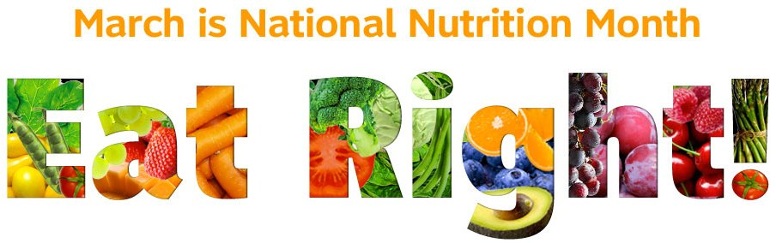
Food, Nutrition and Health Tips from the Academy of Nutrition and Dietetics
Cook more, eat out less
Eating out can be expensive, and many foods can be prepared for a lot less money (and healthier) at home. Pre-packaged foods, like frozen dinners and packaged pasta or rice mixes can also add up when you calculate the cost per serving. It’s better to find a few simple and healthy recipes that you enjoy and save convenience items and eating out for special occasions.
Plan what you’re going to eat
Deciding on meals and snacks before you shop can save both time and money. Review recipes and make a grocery list of what ingredients are needed, then check to see what foods you already have and make a list for what you still need to buy. Plus, when shopping with a list you will be less likely to buy things that are not on it. To “Create a Grocery Game Plan”, visit www.ChooseMyPlate.gov.
Shop for foods that are in season
Fresh fruits and vegetables that are in season are usually easier to get and may be a lot less expensive. Frozen and canned produce are also good options and may be more affordable at certain times of the year. Look for fruit that is canned in 100% juice or water and canned vegetables that are labeled "low in sodium" or "no salt added".
Watch portion sizes
Eating too much of even lower cost foods and beverages can add up to extra dollars and calories. Use smaller plates, bowls and glasses to help keep portions under control. Fill half your plate with fruits and vegetables and the other half with grains and lean meat, poultry, seafood or beans. This is an easy way to eat a balanced meal while controlling portions and cost. To complete the meal, add a glass of fat free or low-fat milk or a serving of fat-free yogurt for dessert.
Focus on nutritious, low-cost foods
Certain foods tend to be less expensive, so you can make the most of your food dollars by finding recipes that use the following ingredients: beans, peas, and lentils; sweet or white potatoes; eggs; peanut butter; canned salmon, tuna or crabmeat; grains such as oats, brown rice, barley or quinoa; and frozen or canned fruits and vegetables.
Make your own healthy snacks
Convenience costs money, so many snacks, even healthy ones, usually cost more when sold individually. Make your own snacks by purchasing large tubs of low-fat yogurt or cottage cheese and dividing them into smaller containers. For trail mix, combine unsalted nuts, dried fruit and whole grain pretzels or cereal; store small portions in airtight containers. Air-popped popcorn and whole fresh fruits in season also tend to cost less compared to pre-packaged items.
Quench your thirst with water
Water from the tap is a low-cost way to stay hydrated. Substituting plain water in place of sweetened beverages can not only save you money but also help you reduce extra calories from added sugars.
One more tip from your PACE RDs: Not a fan of plain water? Try a liquid water enhancer. A 1.6oz bottle costs around $3.00 and can flavor 24 glasses of water without adding sugar or calories.

