PACE CNY
Therapeutic Recreation (TR)
Virtual Calendar January 2021

Therapeutic Recreation Staff:
Director of Therapeutic Recreation
Orion Roeder, CTRS oroeder@lorettosystem.org 315-413-3330
Sally Coyne (P1) Recreation Therapists:
Kristin Dohner, CTRS kdohner@lorettosystem.org 315-413-4508
McKenzie Boyer, CTRS mboyer@lorettosystem.org 315-413-4534
Creek Circle (P2) Recreation Therapists:
Kate Marzinsky, CTRS kmarzinksy@lorettosystem.org 315-413-3303
Krystle Wood, CTRS kwood2@lorettosystem.org 315-413-3305
Natalie Maloney, CTRS nmaloney@lorettosystem.org 315-413-3365

ALL ZOOM GROUPS NOW USE PMI 724 371 9812
To Join By Phone:
- Dial 1-929-205-6099 US (New York)
  - A voice will say “Welcome to ZOOM”
- Meeting ID: 724 371 9812, THEN #
- (Enter Your Participant ID or #,) PRESS #
- Enter Your Passcode: 0, then #
COVID-19 Scam Alert
- You likely will not need to pay anything out of pocket to get the vaccine during this public health emergency.
- You cannot pay to put your name on a list to get the vaccine.
- You cannot pay to get early access to the vaccine.
- No one from Medicare or the Health Department will contact you.
- No one from a vaccine distribution site or health care payer, like a private insurance company, will call you asking for you Social Security number or your credit card or bank account information to sign you up to get the vaccine.
- Beware of providers offering other products, treatments, or medicines to prevent the virus. Check with your healthcare provider before paying for or receiving any COVID-19 related treatment.
- If you get a call, text, email – or even someone knocking on your door – claiming that they can get you early access to the vaccine, STOP. That’s a scam.
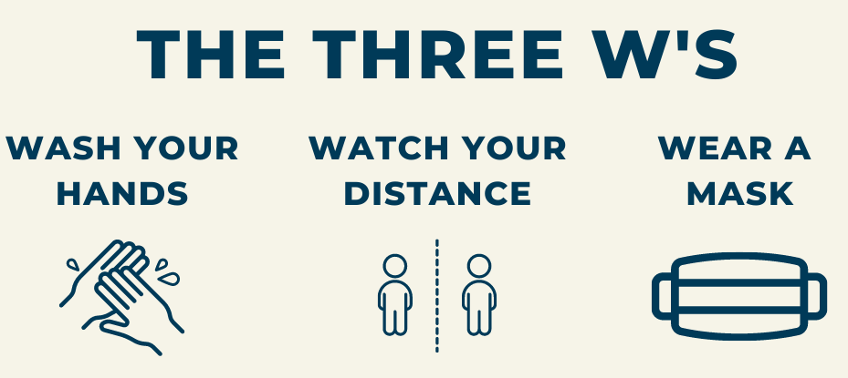

Check out the PACE CNY Website!
www.pacecny.org

Stay up to date with pictures of what participants and staff have been up to!

Download the latest version of the PACE CNY TR Calendar to view in full color, adjust the magnification, and easily follow hyperlinks!
https://pacecny.org/services/day-care/
-------------------------------------------
Be our Pen Pals!
We can’t wait to hear from you!
McKenzie, Kristin, or Orion
Attention: (Staff Member Name Here)
PACE CNY
100 Malta Lane
North Syracuse, NY 13212

Kate, Krystle, Natalie, or Orion
Attention: (Staff Member Name Here)
PACE CNY
115 Creek Circle
East Syracuse, NY 13057
Therapeutic Recreation is encouraging you to get creative during this time of social distancing. We have made a space to display your work at the day center. We are so excited to see what you’ve been up to!

What counts as a creative work?
- Coloring pages
- Painting
- Short story
- Poems
- Drawing
- Anything else you made and feel proud of!
You can mail your work to the day center (address below), have it picked up, or bring it in when we are back together.
Therapeutic Recreation
100 Malta Ln
North Syracuse, NY 13212

Yahtzee Tournament!
Thursday, January 14th at 2pm

How to Play:
- Let Krystle know you are interested in playing, and if you need dice by Monday, January 11th (315) 413-3305.

- On Thursday, January 14th at 2PM, join us by Zoom, Facetime, or phone to play one group game.

- The two people with the highest scores will have a play-off game immediately following the group game.

- Anyone can tune in to watch the play-off!

Krystle Wood: (315) 413-3305 or kwood2@lorettosystem.org

Join Recreation Therapists using ZOOM or call their extension! (11am, 1pm & 2pm daily)

Friday, January 1st
New Year’s Day!

Monday, January 4th
11:00- Share Your Memories with Natalie
1:00- It’s a New Year Stretch! with Kate
2:00- Wheel of Fortune with Kristin

Tuesday, January 5th
11:00- Tai Chi for Beginners with Kristin
1:00- Virtual Bingo with Kate
2:00- Seated Exercise with McKenzie
4:00- Creative Writing with Orion

Wednesday, January 6th
11:00- Tai Chi with Orion
1:00- You Be The Judge with Kate
2:00- Healthy Swaps with Natalie

Thursday, January 7th
11:00- Morning Movement with Kate
1:00- “Snow” Much Trivia with McKenzie
2:00- Guess the Word with Kristin

Friday, January 8th
11:00- Would You Rather with Kristin
1:00- Thumbs Up, Thumbs Down with Kate
2:00- Elvis Presley’s Birthday Party with Natalie
2:00- Bible Study with Don

Monday, January 11th
11:00- Learn Your Name in Morse Code with McKenzie
1:00- Virtual Bingo with Natalie
2:00- Jeopardy! with Krystle
4:00- Wii Bowling Head to Head Challenge with Orion

Tuesday, January 12th
11:00- Tai Chi for Beginners with Kristin
1:00- Kapow!: The Legacy of Batman with Krystle
2:00- What’s a Life Review? with Kate
4:00- Creative Writing with Orion

Wednesday, January 13th
11:00- Tai Chi with Orion
1:00- Reminiscing: The Golden Age of Radio with Krystle
2:00- Snowy Scattergories with McKenzie

Thursday, January 14th
11:00- Most Likely To (Pet Edition)… with Natalie
1:00- How About Some GOOD News with Kate
2:00- Yahtzee Tournament Play-offs with Krystle

Friday, January 15th
11:00- Morning Movement with Kate
1:00- The Fish Bowl Game with McKenzie
2:00- Ice Cream and Personalities with Krystle
2:00- Bible Study with Don

Monday, January 18th
Martin Luther King Jr. Day
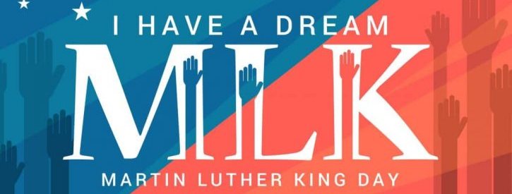

Tuesday, January 19th
11:00- Tai Chi for Beginners with Kristin
1:00- Country Music Hour with Natalie
2:00- Buzzword with McKenzie
4:00- Creative Writing with Orion

Wednesday, January 20th
11:00- Tai Chi with Orion
1:00- Virtual Bingo & February Program Ideas with Kristin
2:00- Picture This? with Krystle

Thursday, January 21st
11:00- Seated Cardio Kickboxing with McKenzie
12:00- Live Virtual Tour with Orion (Sign Up)
1:00- Trivial Pursuit with Kristin
2:00- Organizational Hacks & Fall Prevention with Natalie
3:00- Maverick Book Club with Orion

Friday, January 22nd
11:00- Seated Exercise with Kate
1:00- Virtual Bingo with Krystle
2:00- Ways to be Happy with Kristin
2:00- Bible Study with Don

Monday, January 25th
11:00-Seated Yoga with Kate
1:00- Opposites Game with McKenzie
2:00- Share your Hobby with Krystle
4:00 The Dice Game & Trivia with Orion

Tuesday, January 26th
11:00- Tai Chi for Beginners with Kristin
1:00- The Funny 40’s with Krystle
2:00- Star Gazing with Natalie
4:00- Creative Writing with Orion

Wednesday, January 27th
11:00- Tai Chi with Orion
1:00- Name That Tune with Krystle
2:00- Guided Imagery with McKenzie

Thursday, January 28th
11:00- What Would You Say… with Natalie
1:00- Virtual Bingo & Participant Council with Orion
2:00- Good News with Kate

Friday, January 29th
11:00- Virtual Bingo & 1940’s Slang with McKenzie
1:00- Hymn Sing with Natalie
2:00- Remembrance Service with Orion and Don

January Religious & Cultural Observances
January 1: Feast Day of St. Basil, a holiday observed by the Eastern Orthodox Church, commemorating the death of Saint Basil the Great.
January 3: Feast of the Holy Name of Jesus, which is celebrated in the Roman Catholic Church, commemorates the naming of the child Jesus.
January 5: Guru Gobind Singh Ji’s birthday, the Tenth Guru of the Sikhs who initiated the Sikhs as the Khalsa (the pure ones) and is known as the Father of the Khalsa.
January 5: Twelfth Night, a festival celebrated by some branches of Christianity that marks the coming of the Epiphany.
January 6: Epiphany or Dia de los Reyes (Three Kings Day), a holiday observed by Eastern and Western Christians that recognizes the visit of the three wise men to the baby Jesus 12 days after his birth.
January 13: Lori-Maghi, an annual festival celebrated by the Sikhs commemorating the memory of 40 Sikh martyrs.
January 17: World Religion Day, observed by those of the Bahá’í faith to promote interfaith harmony and understanding.
January 18: Martin Luther King Jr. Day commemorates the birth of Martin Luther King Jr., the recipient of the 1964 Nobel Peace Prize and an activist for nonviolent social change until his assassination in 1968.
January 18-25: The Week of Prayer for Christian Unity, during which Christians pray for unity between all churches of the Christian faith.
January 19: Timkat, a holiday observed by Ethiopian Orthodox Christians who celebrate the baptism of Jesus in the Jordan River on Epiphany.
Religious & Cultural Observances Cont.
January 26: Republic Day of India recognizes the date the Constitution of India came into law in 1950, replacing the Government of India Act of 1935. This day also coincides with India’s 1930 declaration of independence.
January 27: The International Day of Commemoration to remember the victims of the Holocaust. The anniversary of the liberation of the Auschwitz death camp in 1945 and U.N. Holocaust Memorial Day.
January 27 (sundown to sundown): Holocaust Remembrance Day, a time to “mourn the loss of lives, celebrate those who saved them, honor those who survived, and contemplate the obligations of the living.” — Former President Barack Obama.
January 27 (sundown to sundown): Tu B’shevat or or Rosh HaShanah La'Ilanot, a Jewish holiday recognizing “The New Year of the Trees.” It is celebrated on the 15th day of the Hebrew month of Shevat. In Israel, the flowering of the almond tree usually coincides with this holiday, which is observed by planting trees and eating dried fruits and nuts.
January 28: Mahayana New Year, a holiday celebrated by the Mahayana Buddhist branch, on the first full-moon day in January.

Live Virtual Tourism Group Forming!
Where would you like to visit in Onondaga County?

-The highest point? Morgan Hill
https://www.anyplaceamerica.com/directory/ny/onondaga-county-36067/

-Waterfalls? Pratts Falls, Tinker Falls, Marcellus Falls

-A tour of the tallest trees in the county?
- Wizard of Oz Memorial Oak Grove, N. Syracuse
- North Syracuse Cemetery Oak Grove
- Liverpool, 400 Year Old 120’ Tree, 30 Years old when the Pilgrims landed in Plymouth!
- https://www.syracuse.com/outdoors/2017/05/tree_story.html

-Beaver Lake Nature Center?

What is a hidden gem that not many people know about?

We can hit points along the way! The house where you grew up, the best sledding hill, the park where you had your first kiss?
https://www.syracuse.com/opinion/2010/02/memories_of_the_way_we_were_ce.html

Please sign up with Orion & vote for your destination!
1st Virtual Tour Thursday, January 21st @ 12pm
The Tuliptree Cathedral: Green Lakes (145’ Tree)
Friday, January 1st
NEW YEAR’S DAY!!!!

************************************
Monday, January 4th
National Spaghetti Day
Word Mining:
Relationship
Trivia:
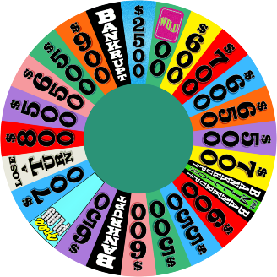
The song “Oh, What a Beautiful Mornin’” is from what musical?
Buy a Vowel:
Ch_c_l_t_
Video/Call-In Groups:

11:00- Share Your Memories with Natalie
1:00- It’s a New Year Stretch! With Kate
2:00- Wheel of Fortune with Kristin
Tuesday, January 5th
National Bird Day

Trivia:
What device did millions of Americans use to “tune” in to hear their favorite news and entertainment programs?

Riddle:
I help you from your head to your toe. The more I work, the smaller I grow.

Video/Call-In Groups:

11:00- Tai Chi for Beginners with Kristin
1:00- Virtual Bingo with Kate
2:00- Seated Exercise with McKenzie
4:00- Creative Writing with Orion
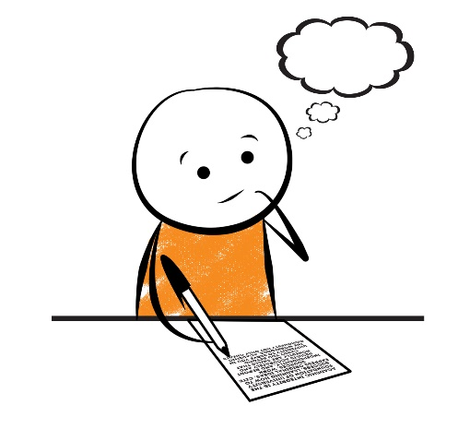

Wednesday, January 6th

Word Mining:
Mountain

Trivia:
True or false? CBS stands for Columbia Broadcasting System?

Buy a Vowel:
W_ndsh_ _ld w_p_r

Video/Call-In Groups:

11:00- Tai Chi with Orion
1:00- You Be the Judge with Kate
2:00- Healthy Swaps with Natalie
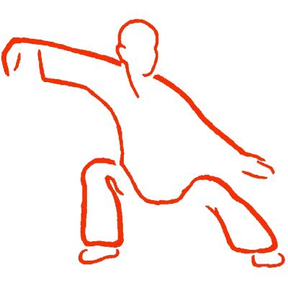
Thursday, January 7th
National Old Rock Day

Word Unscramble:
tvomie

Trivia:
What cultural icon represented the women who worked in factories and shipyards during World War II?

Riddle:
What has to be broken before you can use it?

Video/Call-In Groups:

11:00- Morning Movement with Kate
1:00- “Snow” Much Trivia with McKenzie
2:00- Guess the Word with Kristin

Friday, January 8th

Word Mining:
Authority

Trivia:
What river featured prominently in Mark Twain’s writings?

Friday Funny:
What word in the dictionary is spelled incorrectly?
Incorrectly

Video/Call-In Groups:

11:00- Would You Rather with Kristin
1:00- Thumbs Up, Thumbs Down with Kate
2:00- Elvis Presley’s Birthday Party with Natalie
2:00- Bible Study with Don

Monday, January 11th

Word Unscramble:
ttkony

Trivia:
What cartoon character made his debut in the animated short film Steamboat Willie?

Riddle:
I have a bed but I never sleep. I have a mouth but I never speak. What am I?

Video/Call-In Groups:

11:00- Learn Your Name in Morse Code with McKenzie
1:00- Virtual Bingo with Natalie
2:00- Jeopardy! with Krystle
4:00- Wii Bowling Challenge with Orion
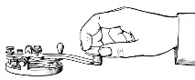
Tuesday, January 12th

National Hot Tea Day

Word Mining:
Penguin

Trivia:
Finish the phrase: “Look before _____.”
- the sun shines
- you leap

Name Three:
Types of tea

Video/Call-In Groups:
11:00- Tai Chi for Beginners with Kristin
1:00- Kapow! The Legacy of Batman with Krystle
2:00- What’s a Life Review? with Kate
4:00- Creative Writing with Orion

Wednesday, January 13th
Word Unscramble:
lafnoweks

Trivia:
In the children’s game Pin the Tail on the Donkey, what must the player wear to participate: a tail or a blindfold?

Riddle:
Forwards I am heavy, I sure weigh a lot. But when I'm backwards, I certainly am not. What am I?

Video/Call-In Groups:
11:00- Tai Chi with Orion
1:00- Reminiscing: The Golden Age of Radio with Krystle
2:00- Snowy Scattergories with McKenzie

Thursday, January 14th
National Dress up Your Pet Day

Trivia:
What word can refer to both a sovereign head of state and a butterfly: duke or monarch?
Word Mining:
Costume

Video/Call-In Groups:

11:00- Most Likely To (Pet Edition)… with Natalie
1:00- How About Some GOOD News with Kate
2:00- Yahtzee Tournament Play-offs with Krystle
Friday, January 15th
National Bagel Day

Friday Funny:
Where do generals keep their armies?
In their sleevies!

Trivia:
What musician is known as “The March King”?
- Glenn Miller
- John Philip Sousa

Name Three:
Things to put on a bagel

Video/Call-In Groups:

11:00- Morning Movement with Kate
1:00- The Fish Bowl Game with McKenzie
2:00- Ice Cream and Personalities with Krystle
2:00- Bible Study with Don

Monday, January 18th
Martin Luther King Jr. Day

Word Unscramble:
Normed

Trivia:
What famous healer was known as “The Lady with the Lamp”: Florence Henderson or Florence Nightingale?

Riddle:
I have two main bodies and I'm turned all about. When I'm standing still, time will run out. What am I?

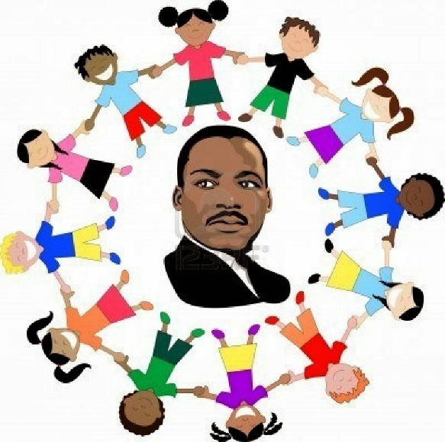
Tuesday, January 19th
National Popcorn Day

Word Unscramble:
Smonwan

Trivia:
What actor won an Academy Award for Best Actor for his portrayal of Atticus Finch?

This Day in History:
On this day in 1966, Indira Gandhi became prime minister of India. She was India’s first female head of government and held that power until her assassination in 1984.

Video/Call-In Groups:

11:00- Tai Chi for Beginners with Kristin
1:00- Country Music Hour with Natalie
2:00- Buzzword with McKenzie
4:00- Creative Writing with Orion

Wednesday, January 20th
National Cheese Lovers Day

Word Mining:
Restaurant

Trivia:
What is the answer to this well-known riddle: What has 18 legs and catches flies?

Buy a Vowel:
P_ct_r_ Fr_m_

Video/Call-In Groups:

11:00- Tai Chi with Orion
1:00- Virtual Bingo & February Program Ideas
with Kristin
2:00- Picture This? with Krystle
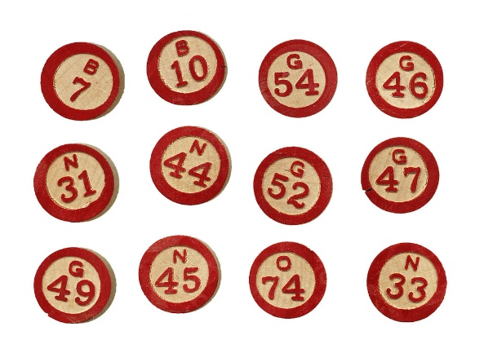

Thursday, January 21st
Word Unscramble:
Kingis

Trivia:
What Italian city has a famous leaning tower?

Riddle:
If a brother, his sister, and their dog weren’t under an umbrella, why didn’t they get wet?

Video/Call-In Groups:

11:00- Seated Cardio Kickboxing with McKenzie
12:00- Live Virtual Tour with Orion (Sign-Up)
1:00- Trivial Pursuit with Kristin
2:00- Organizational Hacks & Fall Prevention with Natalie
3:00- The Maverick Book Club with Orion

Friday, January 22nd

Friday Funny:
How do mountains stay warm? They put on their snow caps!

Trivia:
What vegetable gives Popeye superhuman strength?

This Day in History:
On this day in 1952, the first jet airliner, the British de Havilland Comet, flew its first test flight

Video/Call-In Groups:

11:00- Seated Exercise with Kate
1:00- Virtual Bingo with Krystle
2:00- Ways to be Happy with Kristin
2:00- Bible Study with Don

Monday, January 25th
Opposite Day

Word Mining:
Difference

Trivia:
Which animal is taller: an elephant or a giraffe?

Name Three:
Farm animals

Video/Call-In Groups:

11:00- Seated Yoga with Kate
1:00- Opposites Game with McKenzie
2:00- Share your Hobby with Krystle
4:00- The Dice Game and Trivia with Orion
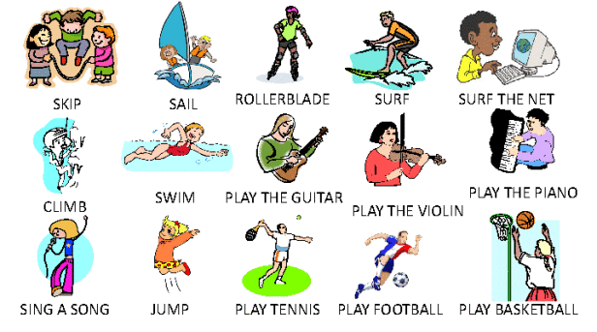
Tuesday, January 26th

Word Unscramble:
bongel

Trivia:
How many total dots are on a pair of traditional dice?

Riddle:
Where does success come before work?

Video/Call-In Groups:

11:00- Tai Chi for Beginners with Kristin
1:00- The Funny 40’s with Krystle
2:00- Star Gazing with Natalie
4:00- Creative Writing with Orion

Wednesday, January 27th
Word Mining:
Rollercoaster

Trivia:
In what mountain range would you travel to climb Mount Everest?

Buy a Vowel:
Cr_ch_t_ng

Video/Call-In Groups:

11:00- Tai Chi with Orion
1:00- Name That Tune with Krystle
2:00- Guided Imagery with McKenzie

Thursday, January 28th

Trivia:
What king in Greek mythology could turn whatever he touched into gold: King Arthur or King Midas?

Word Unscramble:
Treniw

On This Day:
Scottish explorer David Livingstone set off for Africa to find the source of the Nile. All contact with him was lost until 1871, when reporter Henry Stanley finally located him. Stanley greeted him with the famous remark, “Dr. Livingstone, I presume?”

Video/Call-In Groups:

11:00- What Would You Say… with Natalie
1:00- Virtual Bingo & Participant Council with Orion
2:00- Good News! with Kate

Friday, January 29th
National Puzzle Day

Word Mining:
Holiday

Trivia:
True or false? The peso is the official currency of France.

Friday Funny:
Why did the girl keep her saxophone out in the snow? Because she wanted to play cool jazz!

Video/Call-In Groups:

11:00- Virtual Bingo & 1940’s Slang: McKenzie
1:00- Hymn Sing with Natalie
2:00- Remembrance Service with Orion and Don
