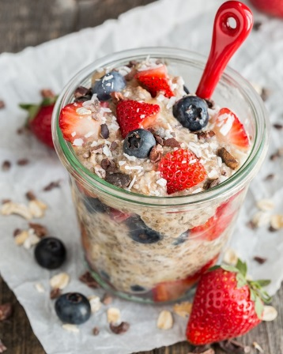
Overnight Oats

You can adjust this recipe based on your preferences.
Eat cold or warmed in the microwave.

Base
1/3 cup oats
½ cup milk (cow's, coconut, soy, almond)
1 tsp chia seeds
1 tsp cinnamon

Extras

Fruit (recommend ¼ cup) Fresh or Frozen (mash or cut into bite size pieces)
- 1/2 Banana
- Peach or Nectarines
- Strawberries
- Pineapple
- Cantaloupe
- Cherries (remove pit)
- 1 tbsp Raisins
- Blueberries
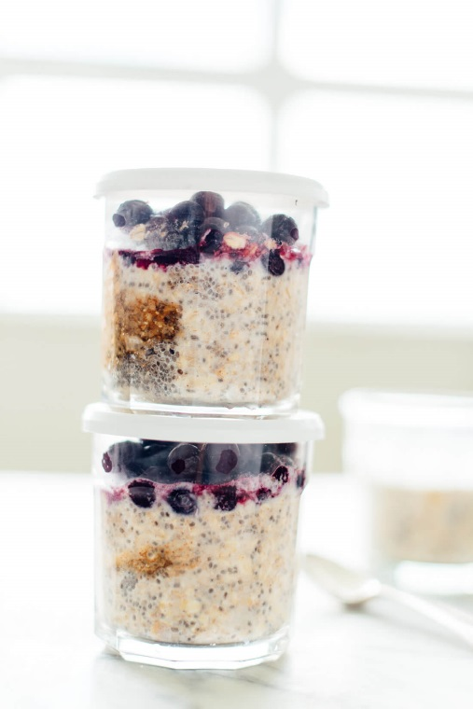
- Raspberries
- Dried Fruit

Sweetener (to taste) start with 1 tsp.
- Maple syrup
- Honey
- Brown sugar
- Coconut sugar
- Stevia

Protein

- 2 tbsp. Peanut Butter
- 1 tbsp. Chopped Nuts
- 3 oz. cup Yogurt – plain or flavored (reduce milk to 1/3 cup)

Other

- 1 tbsp. Shredded Coconut
- 1 tbsp. Milled Flax Seed (nutty flavor)
- 1/8 tsp. vanilla extract
- 1/8 tsp. Salt
- 1 tbsp. Chocolate chips
- 1 tbsp. Oat Bran

Mix base together. Mix in extras & refrigerate for at least 5 hours. Leave in refrigerator for up to 3- 4 days.
Helpful hints
- If using fresh fruit, cover the fruit with the base mix to prevent browning.
- Remember adding the “extras” in will increase the calories. So if you are watching your calorie intake limit the “extras”.
- If you prefer thicker oats, reduce the milk to 1/3 cup or increase the chia seeds.
- Mash the fruit so that the oats can pick up the flavor better.
- Really any fruit will do. Make sure you wash your fresh fruit.
- Apples can be used but heated in the microwave until soften for better results.
- When heating try 30 seconds first and then 10 seconds until soft
- If using frozen fruit, let the measured amount thaw in the refrigerator overnight-- it will be softer and easier to mash

Fun Ideas
Banana with Peanut Butter
Pecan and Coconut
Light Strawberry Flavored Yogurt with Frozen Berry Mix
Walnuts and Honey
Softened Apples with Brown Sugar
Dried Fruit Medley (sampled with regular milk or almond milk)
Chocolate Chip and Coconut
Frozen Raspberry and Flax Seed
Nectarine with almond milk, milled flax and NO cinnamon
Peanut Butter and Banana with chocolate chip, coconut and wheat germ

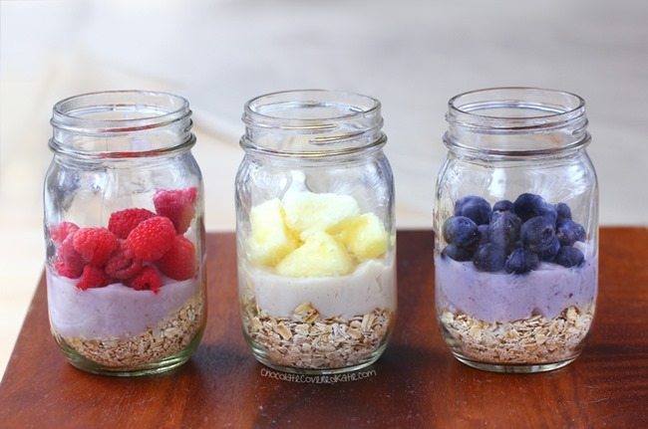

HD 2018

